

Sales Enablement Pack
Cyber Security Operations Centre
The first line of defence

Cyber Security Operations Centre (CSOC) – Sales Enablement Pack

The first line of defence

The threat landscape is continually changing, with businesses becoming more exposed to new threats daily. This puts extra pressure on IT departments that may struggle to efficiently allocate their resources without an internal SOC team.

As an EXPO.e Channel Partner you can offer your customers access to a CSOC Service that utilises continuous threat intelligence and AI to proactively provide real-time security monitoring and alarming services to reduce risk and increase a company’s IT resilience, all managed by experienced security experts.

Why is CSOC Important
- Around 39% of businesses reported having a cyber security breach or attack during 2022.
- Around 52% of business leaders say that they don’t know what to do in the event of a cyberattack.
- The average cost to UK businesses due to cyberattacks in 2022 was £4,180 for smaller businesses, and between £9,270 and £22,700 for larger businesses.
- The CSOC market revenue is estimated to reach $61,199.7 million by the year 2025.
- 30% of businesses reported an increase in cyberattacks during the Covid-19 Pandemic, with 35% of these requiring an incident response.
- Cyber security insurers have dramatically increased their prices, especially for those businesses not actively working to increase their cyber security defences.

Challenges
- Businesses are struggling to keep up with the growing range of complex threats that are emerging.
- IT departments are not able to efficiently allocate resources towards cyber security.
- Organisations need a managed service to look after their infrastructure security, as it can be complex and expensive to maintain an internal SOC team.
- Companies spending time, resource and investments looking for ways and insights to strengthen their security systems that are tailored to their requirements.
- Businesses require additional cyber capabilities, such as endpoint detection and response features.
- The need for additional visibility of their Cloud assets’ security.

Why EXPO.e for CSOC?
- EXPO.e offers a fully managed CSOC solution, using AI and the latest threat intelligence to provide real-time security monitoring and alerting.
- Our solution runs off the platform and software from market-leading vendor AlienVault, now part of the AT&T group.
- Our service detects and reacts to threats in order to provide protection to your customers’ assets.
- We can offer a fully bespoke service, tailored to the customer’s needs and requirements.
- Our CSOC solution uses a Unified Security Management (USM) platform to create a full view of events across your customer’s network, highlighting areas that may benefit from improvement – all within a single pane of glass.
- Through the USM platform, we provide availability monitoring, so if any monitored device goes down or is flapping, we will detect, notify, and act upon this for you and your customers.
- Our systems are also integrated with an advanced persistent threat database, which contains a full list of known vulnerabilities that is continuously updated by all users.
- We have two different options for CSOC Services:
  - CSOC Lite – CSOC Service for Firewalls
  - CSOC USM Anywhere – SaaS-based solution (default option, ideal for most scenarios)
    - Essentials
    - Standard
    - Premium
CSOC Lite
- CSOC Lite is a cost-effective entry point CSOS Solution, focused on monitoring security devices.
- It is a service that collects security logs generated from your customer’s firewall environment to give an overall insight into their security estate.
- Prioritisation of events is set with your customer prior to deployment and reviewed at an agreed frequency.
- Your customer will have a full 24/7 monitoring solution, managed by a team of analysts that will notify them within a 60-minute SLA about any security events produced/seen by the customer’s firewalls.
- You and/or your customer can be given access to a read-only portal to the SIEM.
- Reports can be extracted from the platform, in order to visualise statistical data about any captured event or alarm triggered by the SIEM solution.
- CSOC Lite can cover up to three active and three passive firewalls, if there are any requirements for more than six firewalls or servers, then the full CSOC Service is needed.

CSOC USM Anywhere
- Our CSOC USM Anywhere is the default CSOC option that will suit most use cases.
- Our USM Anywhere Service is a fully managed end-to-end solution that enables centralised security monitoring of networks and devices in the Cloud, on-premises, and in remote locations.
- It enables powerful threat detection and incident response through the use of a single Unified Security Management (USM) platform.
- USM Anywhere’s SaaS-based delivery model provides advantages around reducing deployment, infrastructure and operating costs.
- USM Anywhere price is based on storage, with data logs being stored in a secure Cloud which is encrypted and transferred over a secure connection.
    - As standard we offer 3 levels of USM Anywhere:
      - Essentials – 15 days of real-time event search, with simple fortnightly reports.
      - Standard – 30 days of real-time event search, with monthly reports including trend analysis.
      - Premium - 90 days of real-time event search, with monthly reports including trend analysis.

Why USM Anywhere?
- USM Anywhere’s Cloud-hosted platform provides elastic scalability, so your customers can quickly scale as needed, without having to worry about provisioning or setting up new hardware, which can be time-consuming and require downtime.
Resilience
Increased scalability
Seamless upgrades
Zero server maintenance
- USM Anywhere takes advantage of a highly resilient, fault-tolerant, Cloud infrastructure, thereby mitigating the risks associated with on-premises deployments, such as power outages, hardware failure, human error, and natural disasters.
- USM Anywhere’s highly extensible Cloud platform has been created to support the rapid development and delivery of new features and functionality in response to ever-evolving threat lifecycles, as well as evolving IT requirements, ensuring your customers always have the most effective security monitoring in place.
- Your customers benefit from the rollout of new capabilities and improvements, without the need to manually download and install updates, ensuring they are always utilising the most recent version of the platform, which will include the delivery of new features and functionality to address the ever-evolving threat cycles.
Increased scalability
- As a fully managed SaaS solution, all of USM Anywhere’s underlying infrastructure is centrally managed, so your customers never need to worry about the platform’s hardware or software maintenance, thereby freeing up valuable IT resources.

Features & Benefits
Automated Response Orchestration, providing advanced security orchestration rules that will allow for the automation of actions and responses with direct integration with widely used security tools, such as Cisco Umbrella and Palo Alto Networks. This allows your customers to utilise their existing security investments without spending time and money on integrating systems and writing scripts to allow for automation.
Centralised Security Monitoring – Through USM Anywhere, we can ensure that both your customer’s Cloud and on-premises landscape are fully monitored, so they will not have any security blind spots.
Cloud Native Build – USM Anywhere utilises a unique security element of Public Cloud infrastructure, with the ability to API with many SaaS applications. This allows for greater control over the security of both the Cloud infrastructure and SaaS application.
Cost Savings – Companies can have a lower TCO when investing in EXPO.e’s CSOC USM Anywhere, as there is no CapEx spending on hardware. As USM Anywhere is a SaaS-based platform, upgrades and ongoing hardware maintenance are completed automatically. All of this saves valuable time and resources for your customers’ internal IT teams.
Elastic, Cloud-Based Solution – Allows your customers to scale the solution with their IT environment changes and grow without the need for setting up new hardware, eliminating the downtime for setup.
Endpoint Detection & Response – CSOC USM Anywhere extends threat detection and response to the endpoint. This provides crucial visibility into attacks that might not trigger traditional prevention rules while eliminating the cost and complexity of adding yet another endpoint solution.
Security Analytics – The platform allows for custom search and views, to provide compliance-ready reporting and analysis, to investigate incidents easily.
Single SaaS Platform – Within a single pane of glass, you and/or your customers are able to view all of their security posture information, without the need for multiple logins.

AlienApps
Our service offers a highly extensible platform that enables our CSOC team to deliver AlienApps (modular software components), that extends the USM’s threat detection and security orchestration capabilities to other IT and security applications. This means we can provide your customers with an end-to-end security monitoring and response service, while seamlessly integrating with new applications as and when they become available on AlienApps.


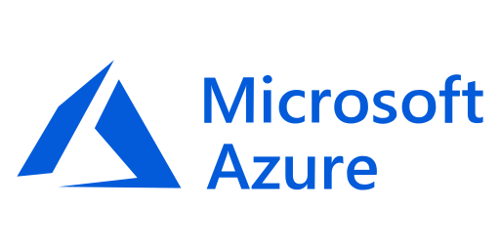







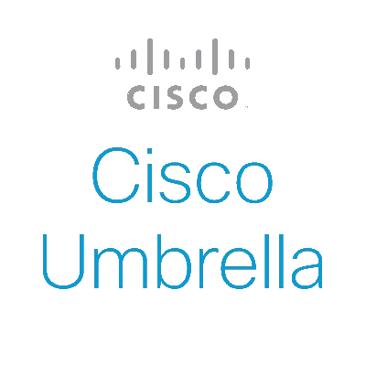



IT Security

Cloud Infrastructure

IT Virtualization

IT Operations

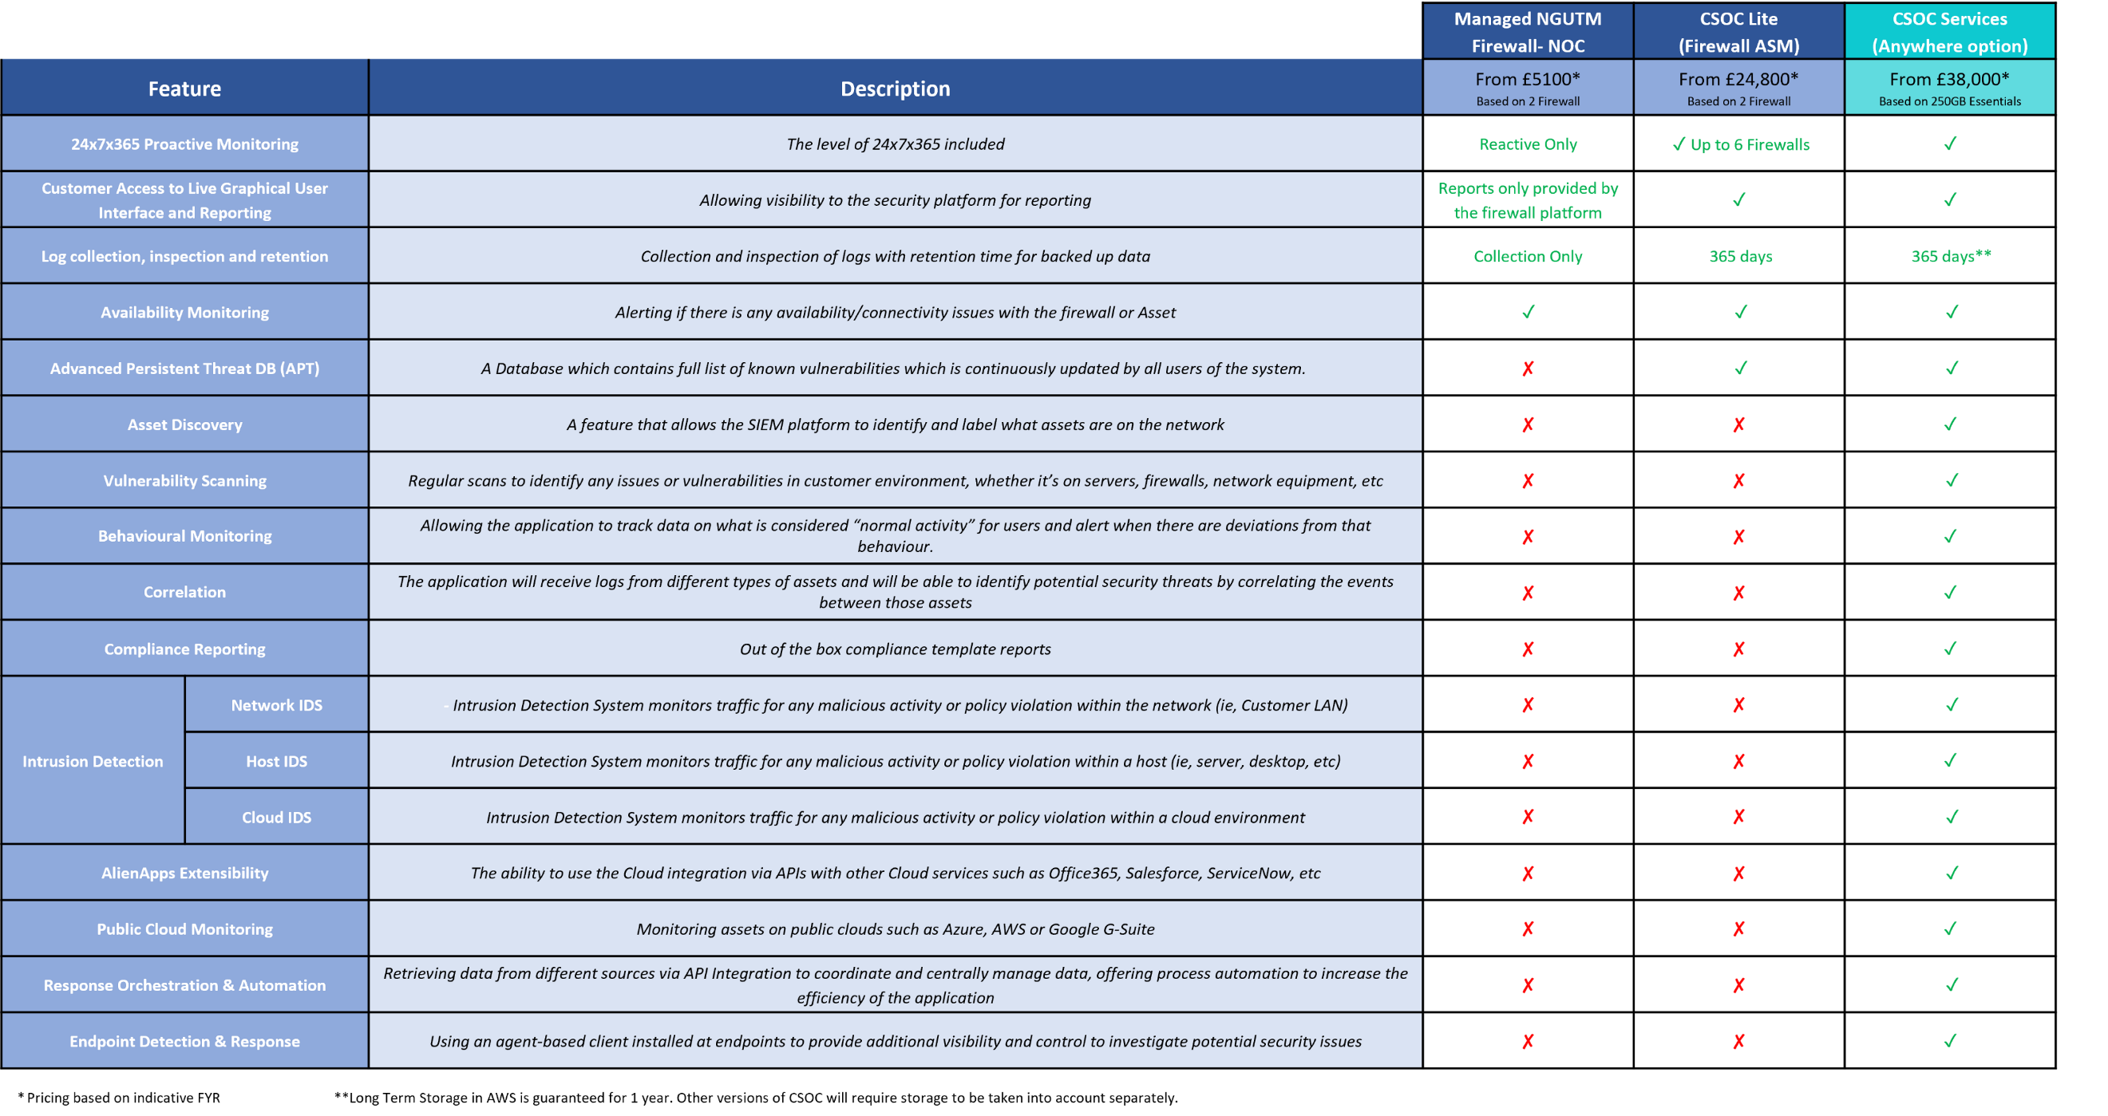
Features Matrix
Managed NGUTM Firewall- NOC |  |  |  | CSOC Lite  (Firewall ASM) | CSOC Services  (Anywhere option)
Feature |  | Description | From £5100*  Based on 2 Firewall | From £10,700*  Based on 2 Firewall | From £45,000*  Based on 250GB Essentials
24x7x365 Proactive Monitoring |  | The level of 24x7x365 included | Reactive Only | ✓ Up to 6 Firewalls | ✓
Customer Access to Live Graphical User Interface and Reporting |  | Allowing visibility to the security platform for reporting | Reports only provided by the firewall platform | ✓ | ✓
Log collection, inspection and retention |  | Collection and inspection of logs with retention time for backed up data | Collection Only | 365 days | 365 days**
Availability Monitoring |  | Alerting if there is any availability/connectivity issues with the firewall or Asset | ✓ | ✓ | ✓
Advanced Persistent Threat DB (APT) |  | A Database which contains full list of known vulnerabilities which is continuously updated by all users of the system. | ✘ | ✓ | ✓
Asset Discovery |  | A feature that allows the SIEM platform to identify and label what assets are on the network | ✘ | ✘ | ✓
Vulnerability Scanning |  | Regular scans to identify any issues or vulnerabilities in customer environment, whether it’s on servers, firewalls, network equipment, etc | ✘ | ✘ | ✓
Behavioural Monitoring |  | Allowing the application to track data on what is considered “normal activity” for users and alert when there are deviations from that behaviour. | ✘ | ✘ | ✓
Correlation |  | The application will receive logs from different types of assets and will be able to identify potential security threats by correlating the events between those assets | ✘ | ✘ | ✓
Compliance Reporting |  | Out of the box compliance template reports | ✘ | ✘ | ✓
Intrusion Detection | Network IDS | - Intrusion Detection System monitors traffic for any malicious activity or policy violation within the network (ie, Customer LAN) | ✘ | ✘ | ✓
Intrusion Detection | Host IDS | Intrusion Detection System monitors traffic for any malicious activity or policy violation within a host (ie, server, desktop, etc) | ✘ | ✘ | ✓
Intrusion Detection | Cloud IDS | Intrusion Detection System monitors traffic for any malicious activity or policy violation within a cloud environment | ✘ | ✘ | ✓
AlienApps Extensibility |  | The ability to use the Cloud integration via APIs with other Cloud services such as Office365, Salesforce, ServiceNow, etc | ✘ | ✘ | ✓
Public Cloud Monitoring |  | Monitoring assets on public clouds such as Azure, AWS or Google G-Suite | ✘ | ✘ | ✓
Response Orchestration & Automation |  | Retrieving data from different sources via API Integration to coordinate and centrally manage data, offering process automation to increase the efficiency of the application | ✘ | ✘ | ✓
Endpoint Detection & Response |  | Using an agent-based client installed at endpoints to provide additional visibility and control to investigate potential security issues | ✘ | ✘ | ✓

Discovery questions to ask your customer
What specific compliance requirements do you need to adhere to?
How are you looking to enhance your infrastructure?
When was the last time you were audited, or had a professional security professional assessment?
Are you currently getting security visibility of your endpoints through other mechanisms?
Does your company have a Cloud migration strategy in place and, if so, what are the time frames?
Has your company adopted a working from home policy, or other changes driven by the recent pandemic?

Qualification questions to ask your customer
How many devices does your organisation use, and how many of them are Windows servers, laptops, firewalls, etc.?
Do you need to monitor endpoints outside of the network or in remote locations?
Would you like the ability to query devices for additional forensic data as part of your investigation activities?
Would you like our partner, EXPO.e, to actively monitor endpoints, which will include active process and network activity?

