

Sales Enablement Pack
Disaster Recovery as-a-Service
A truly bespoke approach to DRaaS

Server Replication (DRaaS) – Sales Enablement Pack

A truly bespoke approach to DRaaS

An all-in one Disaster Recovery (DR) solution providing continuous data protection, enabling ongoing operations through any disruptive event, and delivering workload mobility. Offer your customers unparalleled application availability and drive business continuity to minimise losses resulting from downtime with EXPO.e’s Cloud-based solution.

What is Disaster Recovery as-a-Service?

A data centre recovery solution designed to capture a point-in-time copy (backup) of an enterprise workload and write the data out to a secondary storage device for the purpose of recovering this data in the future. This allows IT systems to be recovered following an outage, or data to be recovered following following deletion or corruption.

Why is Disaster Recovery Important?
- 33% of companies that have DR measures in place don’t test periodically to ensure these are working. Not every company has the resources or knowledge to carry out these processes.
- Robust DR strategies support business growth, as being able to demonstrate a credible DR pedigree through certified processes helps your customer’s credibility, enabling them to win larger deals.
- 50% of smaller businesses do not survive a significant disaster event (e.g. ransomware, data breaches, etc.) In contrast, 96% of businesses with a DR practice in place do fully recover.
- 75% of small businesses have no DR plan in place. It may fall into the ‘nice-to-have’ category, until they need to use it…

Market Information
Distributed Cloud is a key strategic technology trend.
The global Disaster Recovery as-a-Service (DRaaS) market is expected to grow from $5.1Bin 2020 to $14.6B by 2025 (23.3% YOY increase).

The average cost of IT downtime for businesses is about $5,600 per minute.
Integrated risk management is one of top 20 emerging technologies and trends of H1 2023, amongst over 5000 others.

Challenges
- Money – Keeping copies of the same data in multiple locations leads to higher storage and processor costs.
- Time – Implementing and managing a data replication system requires dedicated time from an internal team.
- Bandwidth – Maintaining consistency across data copies requires new procedures and creates additional traffic on the network.


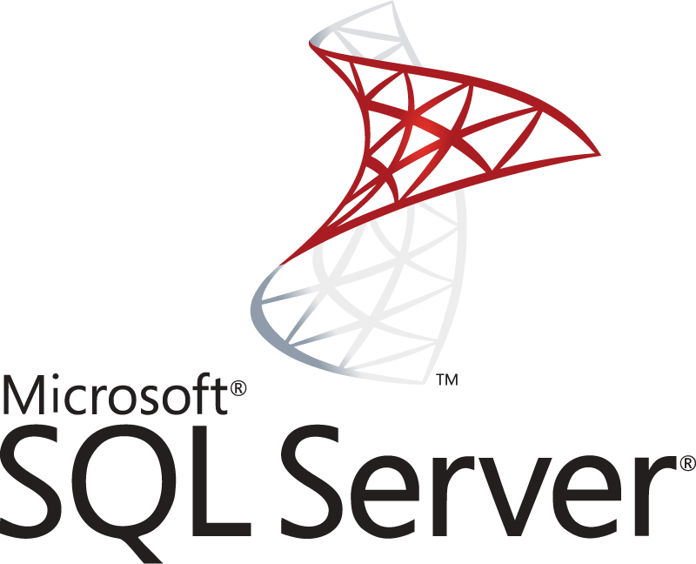
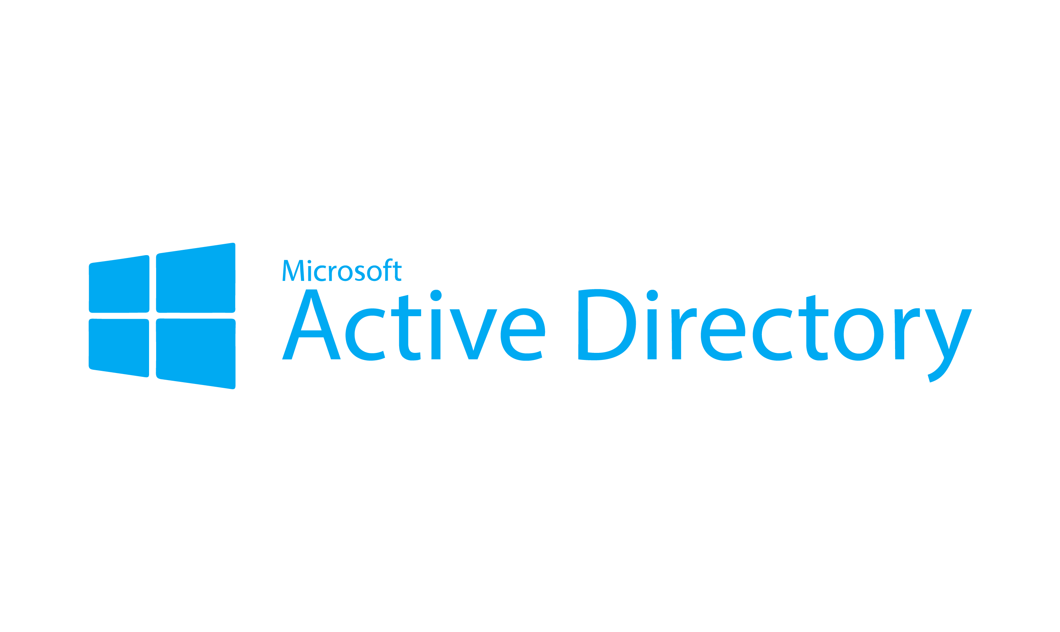
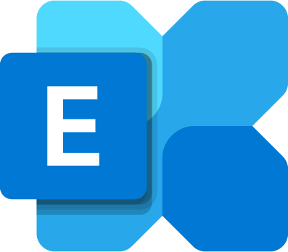
Commercial Challenges
High Availability
Replication
Backup
Cost
PRO / RTO

Why EXPO.e for Disaster Recovery?
- Experienced in delivering best-in-class DRaaS solutions across a variety of use cases and verticals, and currently protecting thousands of VMs in our own environment.
- Platinum partner of Zerto, industry leaders in data centre backup and recovery solutions, to deliver a comprehensive DRaaS solution, backed by our private network.
- Certified Cloud specialists provide detailed Business Continuity Planning (BCP) to reduce the impact of any disruptive events on your customers’ businesses.
- Solutions are tailored to each individual customer’s needs through a solution- and outcome-based approach, starting with an in-depth initial consultation and full support and guidance from our experienced Cloud team.
- Offer customers a complete Business Impact Assessment (BIA) to measure the impact of disruptive events and determine a Recovery Time Objective (RTO) to mitigate this.
- EXPO.e have a demonstrable, certified DR process (ISO 27001, ISO 22301), and are trusted by customers of all sizes, across multiple sectors, including Financial, Legal, and Healthcare.
- Low-risk implementation and migration guaranteed by our team of dedicated Cloud Solutions Consultants, Delivery Experts, and 24x7 UK Support Desk
- A fully managed service, where we manage the underlying infrastructure to reduce you and your customers’ touch time and administrative burden.
- Complementary services available to provide more strategic DR/BC approaches, including private networking, WAN, SDN/SD-WAN, and cyber security – all delivered under a single SLA when buying through EXPO.e.
- Provides a single point of contact across all services, enabling vendor consolidation and simplifying access to support for your customers.
- Multiple Public Cloud environments managed under our Cloud Management Platform (CMP) for the entire replicated estate.

Features & Benefits
Quick Recovery and Failback – Our existing service offers up to 4 hours recovery time as standard: Your customers can benefit from the ability to failback to a point in time beyond this with 7-, 14-, and 28-day journaling options.
Full Service Management – You and/or your customers can have access to our UK Service Desk 24/7x365 with a pre-agreed invocation plan in place, focused around your customer’s dependencies and business priorities, to streamline the recovery process so your customers can focus on matters outside of the IT estate in a DR scenario.
Enhanced Protection – A consistent high-bandwidth connection is key for seamless replication. Leverage our private, enterprise network to deliver this service onto your customers’ existing networks by allowing them to extend their server subnets from their locations into our VDC for a true end-to-end solution.
Cost Savings – Cloud-based solution removes up-front physical hardware costs associated with legacy infrastructure and provides the flexibility to scale resources as required. Your customers only pay for VMs once they are spun up in DR, which reduces costs, as they are not paying for unused resources.
No Performance Impact – Other replication technologies use snapshotting, which has a performance impact at the VM level. Ours works at the hypervisor layer, replicating across to the target storage seamlessly, ensuring there is no service degradation or performance impact on your customers’ workloads.
Easy Isolated Testing – We offer a free yearly DR test and can provide your customers with a sandbox IP subnet isolated where they can perform functional testing without impact to the production environment. Live failover tests can also be performed with minimal disruption.
Flexibility – Your customers have the option of replicating from a single VM to their entire estate and set up Virtual Protection Groups (VPGs) in a cascading order to prompt business-critical servers to failover first. This provides a boot order recovery process in an automated manner.

What is One-to-Many (O2M)?
- One-to-Many feature allows a VM to simultaneously replicate to several other target locations while replicating a local copy.
- Simultaneously protect applications, VMs, and data – locally and across multiple remote sites – from logical failures, human error, and malware attacks.
- Continuous data protection and point-in-time recoverability, with RPO’s of seconds enabling rapid, local or remote recovery, with data retrieved from seconds before its deletion or corruption.

Product Options
 | Product Options – Simple services based on a per VM + storage charge
Existing Replication Options | Standard Replication – Customer Site to VDC | Standard Replication – VDC to VDC | *Excluding Extended Journals where customers only pay for the additional storage required (this is calculated through the Cloud Pre-Sales team) – there is no VM cost. **Only to be sold in addition to Standard Replication or O2M
Existing Replication Options | When to sell:  - Customer intends to keep their on premise environment to retain control  - Neet to host on premises due to legal/regulatory requirements  - They have recently invested in upgrading their on premises hardware | When to sell:  - Customer already hosting their servers on our VDC or a 3rd party VDC  - First steps in embracing the shift to a Cloud-first business IT strategy  - Require the flexibility to scale their protected estate on-demand as their business grows, to manage costs
NEW Options | O2M – One to Many Replication | Extended Journals  (Add-On Only**)
NEW Options | When to sell:  - Tertiary location for customers wanting a completely segregated protection  - Increased flexibility for use of multi cloud to provide increased protection and diversity  - Enhanced options for migrations for multi cloud environments / staging of services as part of a complex migration process  - Ability to bring up services quicker as simultaneous failover can be done at the two locations  - Spin up test environments, outside of the core production replication to allow for simulation, dev scenarios, DR examples etc. | When to sell:  - Protecting against failure overnight / weekend / bank holidays – currently this would require restore from backup  - More robust failback for application upgrades e.g. bad code push, not detected for more than 4 hours  - Ransomware is the number 1 conversation around longer journals  - Human error / admin change that creates impact or corruption  - Forensics reversion (i.e. there was a breach, what happened at x o’clock? Boot up the rollback into sandbox environment and analyse)

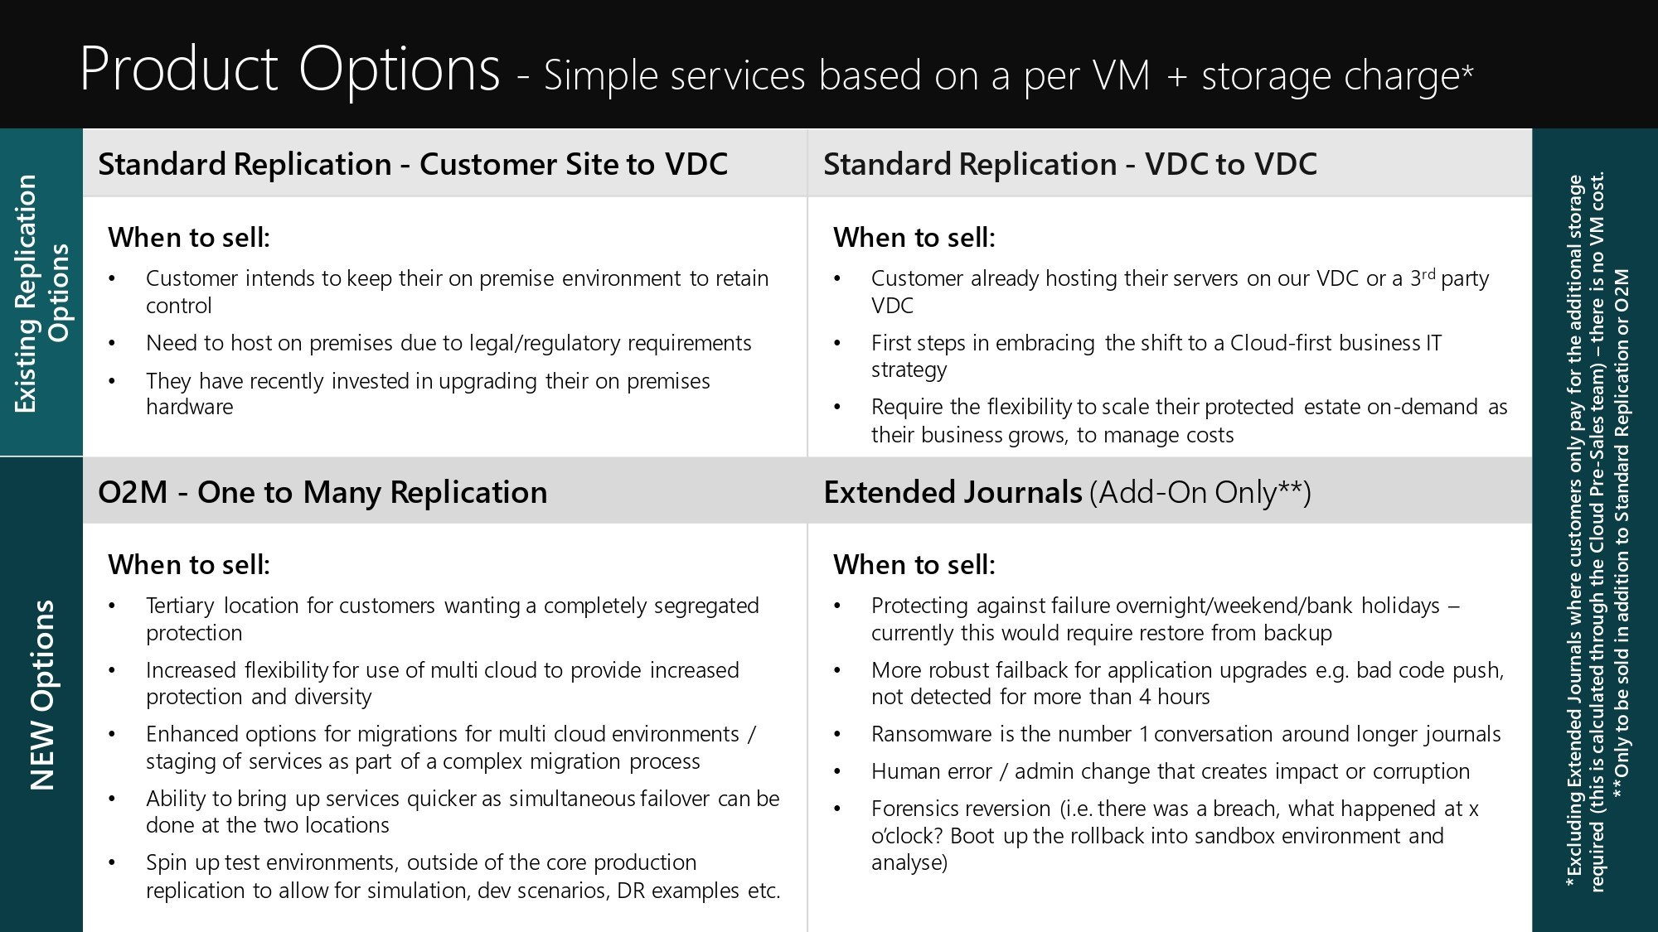

Discovery questions to ask your customer
- Do you know when your organisation last carried out any form of DR test?
- What team, or who would be responsible for that within the organisation?
- What’s the process for a DR test today? (What tech is used?)
- Do you know if it was deemed a success? (How do you measure success?)
- How often do you carry out a full DR test? How long does it take and how many people are needed?
- Do you know if the business has specific RPOs & RTOs that they are looking to achieve?
- What would happen today if the business was down for four hours, what sort of impact would that have?
- What amount of downtime and data loss is acceptable to your business?
- Were the SLA’s set based on what your business needs or the best that IT can deliver?
- Do you tier your servers and applications against importance/criticality?
- How do you protect your critical applications today?
- Do your business applications consist of multiple VM’s and if so, how do you manage application consistent recovery?
- Do you have a specific team that would monitor, protect, and recover against a Ransomware attack?
- Do you have internal ransomware training?
- What would be the current recovery process from a ransomware attack (“it is not if, but when”)?
- How do you manage applications during technology refresh programs?
- How do you carry out migrations?
- How do you mitigate against vendor lock in?
- How do you create copies of production environments to carry out patch testing, upgrades, and/or pen testing?
- What is your Cloud strategy over the next three years?
    - Private, Public, or Hybrid?
    - Consolidation of current DC’s?

Qualification questions to ask your customer
- Focus the conversation on the overall BC/DR strategy.
    - Single points of failure?
- What is their current DR practice?
    - Does it work?
    - Can they test it?
    - Do they have confidence in it?
- Do they have compliance requirements to meet (e.g. FCA obligations)?
- What is the cost of disruption? How much money is the business losing when critical systems are offline?
- Every business needs DR. Try to articulate the cost of IT disruption.
    - Fee earners’ cost per minute?
    - Regulated industries fines and penalties?
- If they are running VMWare, which version (i.e. vSphere/vCentre)?
- If they are running hyperV, which version? Must they also be running a system centre virtual machine manager (SCVMM)?
- Do they have any raw device mappings RDM or in guest iSCSI mapping?
- What number of VM’s do they need to replicate and what storage is assigned?

Qualification Metrics
What key metrics do Presales need to know from the onset to scope out a customer solution?
- Number of servers?
- Total amount of VM Storage (GB/TB) to be protected?
- Customer location and connectivity?
- Which hypervisor they are using (e.g. VMWare)?
- Existing RTOs and RPOs they need to adhere to?

Objection Handling
- “It’s too expensive.”
  - Discuss the potential financial impact of not having a DR/BC solution in place in the event of a disruption and use the Downtime Calculator to support this.
  - Emphasise the cost efficiencies, as with EXPO.e’s Cloud-based solution, the customer only pays for the resources they are actually using.
  - EXPO.e’s solution is less expensive than HA, and enables faster recovery times than traditional backup solutions.
- “It’s not secure.”
  - Data from the journal is copied directly into cost-effective storage environments in EXPO.e’s own Private Cloud via our own highly secure, business-only network.

