

Sales Enablement Pack
Secure Access Service Edge (SASE)
Accelerating your customer’s digital transformation journey

SASE – Sales Enablement Pack

Accelerating your customer’s digital transformation journey

The accelerated increase in remote users and new hybrid working patterns has escalated the need for Cloud-delivered solutions to enable working from anywhere, anytime and any device. Businesses need to ensure that they can provide employees with secure access to their applications while retaining control over data. Our Secure Access Service Edge (SASE) solution helps to accelerate your customer’s digital transformation journey, providing a proven security platform that is data-centric, Cloud-smart and able to support their ongoing growth.

What is Secure Access Service Edge (SASE)?
- As defined by Gartner, Secure Access Service Edge (SASE), pronounced “sassy”, is an emerging framework for the convergence of networking and network security services within a global Cloud-based platform to protect users, applications, and data.
- Due to the COVID-19 pandemic, many businesses had to support a distributed workforce, creating additional security challenges as most of their employees were no longer on the corporate network, and could not depend on conventional hardware appliances at the network edge.
- We have partnered with Gartner-credited SASE providers Palo Alto, Netskope, and Cisco to deliver our SASE Solution.
- Our SASE solution is a Cloud-based web security gateway, that protects the enterprise from the growing volume and sophistication of Cloud-enabled threats and data theft, ensuring users can safely and securely use Cloud apps and the web to go about their daily business tasks.
- Offering a single platform, with unified Cloud-native microservices architecture including elements such as Secure Web Gateway (SWG), Firewall as-a-Service (FWaaS), Cloud Access Security Broker (CASB), Data Loss Prevention (DLP) and threat protection, all built upon a global access network optimised for high performance and maximum user experience.
- The solution protects users accessing the web by detecting threats such as malware, phishing sites, and drive-by exploits, which can easily pass through legacy defences or be whitelisted to bypass defences by leveraging trusted domains with valid certificates.
- Through the use of advanced knowledge of decoding applications and Cloud services for content and context with the added benefit of machine learning, our solution enables your customers to secure themselves against not only known attacks, but also emerging threats.

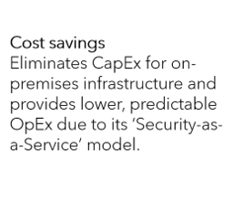
Why SASE?
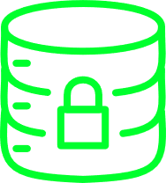

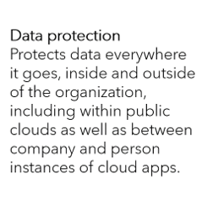

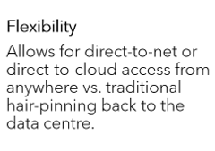
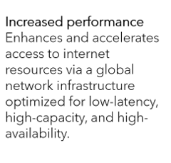



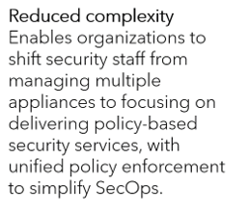


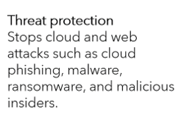


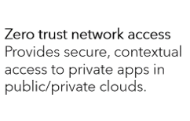

Why EXPO.e for SASE?
- Data-centric Security – A data-centric approach to Cloud security involves following data throughout every step of its journey – from the point of creation through to Cloud apps and personal devices – ensuring the customer’s security policies are applied correctly at all times.
- Cloud-smart Security – Thanks to EXPO.e’s deep contextual understanding of the Cloud, our SASE solution enables your customers’ IT teams to apply effective security controls that allow end users to access Cloud- and web-based platforms securely.
- High-speed Security – Real-time, Cloud-native security that is always on, always effective, and always operating at optimal speeds, in order to stay ahead of the latest threats, allowing you to offer your customers complete peace of mind.
- Advanced Analytics and Reporting – Offer your customers a 360° view of their users’, apps’, and devices’ current security posture, supporting a proactive approach to cyber security.
- Multi-layered Defence – Provide your customers with a range of sophisticated tools – including script analysis and heuristics, and ML-powered anomaly detection – to secure against the latest threats, with support from EXPO.e’s own 24/7, UK-based CSOC.

Traditional Security vs SASE
 | Traditional Security | SASE
Remote Users | Remote access VPN terminating on a centralised, dedicated firewall or VPN concentrator in the enterprise data centre. | SASE acts as a VPN replacement. Users connect to a SASE to access on-premises resources and Cloud services. The customer’s policies are defined and applied through the SASE console.
Enterprise DC | The enterprise DC, centralised in an MPLS-based network is rapidly becoming redundant, with organisations looking to support hybrid working models by bringing security closer to their applications. | Being Cloud-based, SASE provides customers’ end users with optimized access to business-critical SaaS, PaaS, and IaaS platforms.
Traditional Networking | Traditional security models are often built around inflexible networks, with services separated into multiple solutions. | A SASE service integrates SD-WAN access and traffic optimization into a single brokering service for all access types.
Web Security | SWG’s or WAF’s are usually separate platforms or are achieved by brokering to a content delivery network, or in-house Cloud service. | SASE platforms integrate WAF policies and services into the same brokered approach, although polices and capabilities may not be as mature yet.

Features & Benefits
Please note that features below will be solution dependent.
- Analytics & Reporting – Provides advanced analytics and reporting on details such as user activity, location, and file sharing to supporting proactive security measures, e.g. SIEM.
- Antimalware/Antivirus – Antimalware focuses on new threats, while antivirus keeps you protected against the traditional versions, like worms and phishing attacks, that can still harm your device. The two complement each other, with antimalware designed to supplement antivirus protection as the cyber threat landscape becomes more sophisticated.
- Centralised Management – A single-pane-of-glass model allows for efficient control of policies and access across their entire business estate.
- Client Software Agent – Provides secure connectivity from the user to the SASE Cloud for filtering and control.
- Cloud Access Security Broker (CASB) – Helps customers understand what applications are being used in the Cloud, and who is accessing those resources to deliver security controls across SaaS, Web, and IaaS services, and protecting their most sensitive data in the Cloud.
- Data Loss Prevention (DLP) – As an integrated part of the Cloud security framework, modern DLP solutions provide full visibility and context awareness of data movement across Clouds as well as mitigation of loss and exfiltration.
- Domain Name System (DNS) Security – Predictive analytics, machine learning, and automation are used to combat threats in DNS traffic. This allows businesses to block any bad domains, and get a predictive insight into unknown ones, whilst stopping DNS tunnelling.
- Endpoint Detection & Response – Provides real-time alerts to help identify the early stages of an attack, as well as uncover how threats may have evaded existing defences, to help provide information on how to stop future attacks from occurring.
- Firewall as a Service (FWaaS) – Ensures that branch offices are protected from unknown threats, whilst also providing next-gen security features including threat prevention and URL filtering.
- Intrusion Detection & Prevention – Allows security teams to analyse events in your customer’s network for early signs of incidents and threats, enabling intrusion prevention systems to stop any attacks to the IT networks.
- Remote Access for Private Cloud – Enables users to access files and other system resources on any devices or servers that are connected to the network at any time, increasing employee productivity and enabling them to better collaborate with colleagues around the world.
- Sandboxing – Protects the customer’s critical infrastructure from suspicious code because it runs in a separate system. It allows IT teams to test malicious code in an isolated environment to understand how it works within a system as well as more rapidly detect similar malware attacks.
- Secure Web Gateway (SWG) – Our managed solution gives your customer a SWG functionality to provide visibility into their traffic and monitor suspicious activity, while being able to web filter, preventing theft and the sharing of credentials to unknown sources.
- SSL/TLS Inspection – Inspects encrypted web traffic and Cloud services for potential data theft, malware, and advanced threat.
- URL Filtering – Limits access by comparing web traffic against a database to prevent employees from accessing harmful sites, such as phishing pages.
- Web Application Firewall (WAF) – Protects against HTTP application attacks by inspecting HTTP traffic before it reaches applications and protects the business’ servers by filtering out threats that could damage site functionality or compromise data.

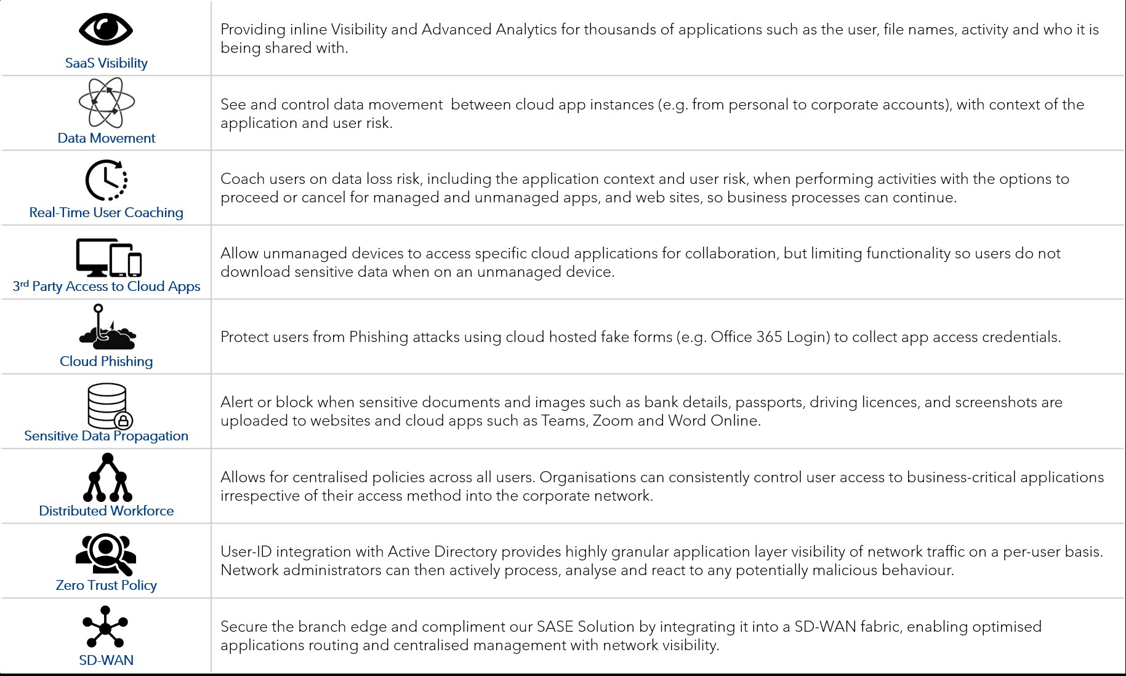


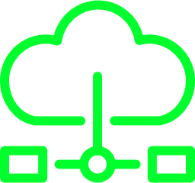
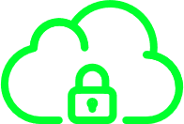



SASE Use Cases
3rd Party Access to Cloud Apps
Cloud Phishing
Distributed Workforce
Zero Trust Policy
SD-WAN
SaaS Visibility
Data Movement
Real-Time User Coaching
Sensitive Data Propagation

Complementary Services

SD-WAN
With the increase of Public and Private Cloud use, it is imperative that WAN performance is at its optimum to cater for mission-critical workloads to ensure business continuity.
Our managed SASE Solution can be integrated with our SD-WAN offering to secure the branch edge. Our offering allows your customers to have security in the Cloud and branch sites, giving the same level protection as at the headquarters. As there is no longer a need to backhaul internet connectivity to the businesses centralised firewalls, your customer benefits from faster access to business-critical applications and information.

CSOC
It is vital that businesses can monitor their network usage for any malicious behaviour, while being able to analyse any data received to proactively put security measures in place.
To optimise our managed SASE solution, your customers can choose to add our CSOC services. Integration into our Security Incident and Event Management (SIEM) platform will require installation of a virtual appliance, which enable logs to be retrieved from the SASE solution, which can then be forwarded over to the syslog server. Our SIEM Platform enables our in-house CSOC team to monitor and respond to any security threats that may be present across the entire business estate, providing a true end-to-end security solution.

Discovery questions to ask your customer
- How does your company deal with remote user requirements?
- What is your current working model? Office-based, remote, or both?
- Have you taken on more Cloud or SaaS Services in the past year?
- Do you have a secure mechanism for accessing the Internet or corporate applications hosted in SaaS, Public or Private Cloud environments?
- Do you want to allow your users to remotely access your corporate applications from their personal devices with secure network access controls in place?
- Do you have a need to monitor network usage for users spread across multiple geographic locations, including a remote workforce?
- Are you working on any digital transformation projects?
- Do you need to contain confidential data (PHI, PII, PCI) within approved Cloud services?
- How many users do you have that are in branch offices and at remote locations?
- Which regions do your employees work within?
- Which applications do your employees use, where are they hosted, and how are they accessed?
- What kind of network security do you have at the moment?
- What kind of remote access solution do you have at the moment?
- Are you concerned about data loss through unapproved Cloud apps (“Shadow IT”)?
- Do you need to identify unsafe Cloud apps, and monitor unsafe user practices?

Qualification questions to ask your customer
We use ATP and MS Security Centre
Problem:  Visibility & Control | How do you monitor and control the type of applications that users can access?
Problem:  Shadow IT | How do you identify the use of other SaaS services outside of Microsoft products by your users?
Problem:  Resource | Do I have the required skillset in Microsoft’s product suite to be able to implement compliance across all of their services?
Problem:  Commercial | Do you have the required licensing from Microsoft to run DLP and to have ATP for all of your users?

We use a corporate VPN Solution
Pain Point:  Capacity | Has your firewall solution been able to cope with a full tunnel solution so that all traffic is diverted back to the corporate firewall?
Pain Point:  Visibility & Control | If you have implemented split tunneling, how is user activity being filtered when they are accessing SaaS type services or even normal web usage?
Pain Point:  Visibility & Control, Lack of regular Patching | Are users logging on regularly to the VPN, particularly if their work requires only for them to access SaaS or Cloud based Services?
Pain Point:  Latency & Performance | Do you have users that have been working from abroad or that have had connectivity issues from their home?

We use a VDI Solution
Problem:  Visibility & Control | How do you prevent users from accessing SaaS or Cloud services directly outside of VDI, when most SaaS services allow access from anywhere?
Problem:  Visibility & Control | How do you keep track of what documents those users have accessed / downloaded to prevent exfiltration of data?
Problem:  Capability & Cost | Is your VDI environment capable of handling the additional load?
Problem:  Capability & Cost | How does that impact your VDI platform sizing?

We use existing SASE Service
Pain Point:  SASE Feature Comparison | What features do you have enabled on this product?
Pain Point:  SASE Feature Comparison | Are you making the most out of your product?
Pain Point:  Commercial Comparison | Is the solution too expensive?
Pain Point:  Resource | Do you have the required skillset to deploy and manage this type of solution?

